

Making Connections:
A one-day community building course

Author: Carl Poll

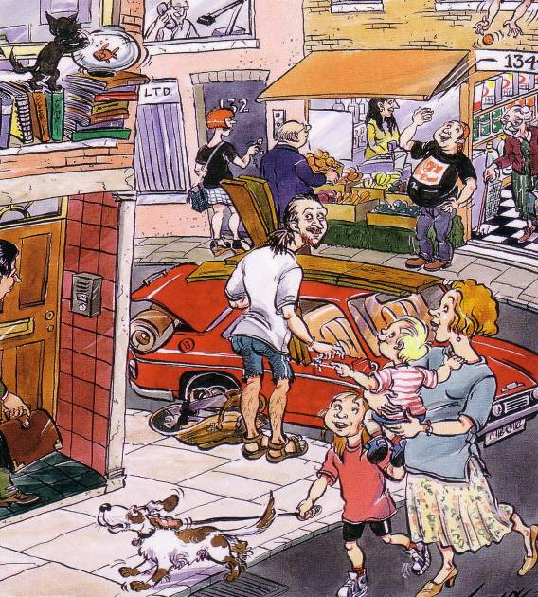

ESSENTIAL VALUES – THE STARTING POINT FOR ‘INCLUSION’

If we close our eyes and make contact with the feelings that come up if we are excluded, we’ll notice that these are generally not positive ones.

For most of us these are not permanent and, hopefully, outweighed by the positive feelings associated with belonging.

For labeled people it’s not the same. For many, exclusion has been a daily experience (often for decades) and the feelings which go with exclusion dominate their lives. Little good can come from this dominance of feelings such as fear, resentment, anger and loneliness.

To enable societies to commit people to a life of exclusion, they need to create justifications for this exclusion. There have been many - a few are:

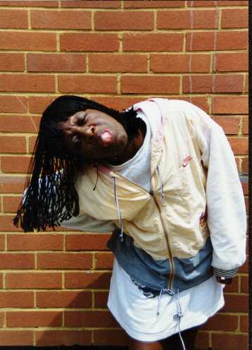

- Financial burden on society
- Genetic threat
- Vulnerable - need protection
- Morally defective
- Economies of scale
- Possessed by devils

ESSENTIAL VALUES

Centuries of such ideas and practice have had a deep impact on the beliefs of ordinary people. Segregation of people in services is widely accepted in our society as the ‘best place for them’.

Sometimes this is crudely expressed; such as in these statements made by people involved in services:

- ”Mentally handicapped people can’t do anything”
- “It’s not fair to the neighbours”
- “People functioning at that level - what can they contribute to the community?”

Other times this prejudice is expressed more softly and in a more sophisticated way.

But, it is so prevalent that just placing people ‘in community settings’ and hoping for the best – hoping that somehow they will automatically be included – may not work.

On the other hand we should not assume people would not be able to forge their own connections. We should be prepared to be surprised.

Susan and Ian showed that they were able to create very strong connections all on their own ……

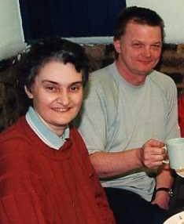
Susan and Ian tell the story of being whisked off in a limo to a west-end hotel on their wedding anniversary. There was a slap-up meal with lots of people, speeches and a cheque.

Who arranged it? Ian just says ‘it was Fred down the market.’

Ian and Susan made these connections because of their own unique abilities and qualities. The role of their support agency – KeyRing –was to create ‘walking around space’.

Walking-around space is hard to define – lots of behind-the-scenes work to help Susan and Ian become confident enough to navigate the local community on their own. Also, constant support to discuss how things are going and what else can be tried when things don’t work out. And much work with the authority to have confidence in Ian and Susan’s capacity to do this without being hemmed in by risk assessments.

Some won’t so easily establish such connections and the course looked at the means of supporting those people to become connected.

ESSENTIAL VALUES

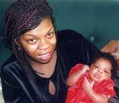
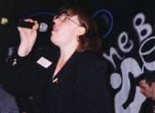
- All born in
- All means all
- Belonging
- Everyone is ready
- Everyone needs support
- Everyone has something to say
- Everyone can contribute
- Together we’re better

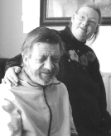
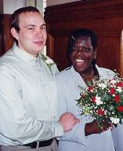

These are the essential values which underpin any serious community building effort – if we are working with people who are labeled and excluded, these values must be our starting point – they are not negotiable.

ASSETS AND DEFICITS

We are all the same – all of us have some deficits and some assets or gifts.

Focusing on one or the other has an effect.
ASSETS AND DEFICITS

In terms of resources, it is critical to work from a gifts approach – an assets approach. John McKnight states very clearly that, for community building purposes:

‘Information about deficits is useless’.

It is also critical to start with assets because community is built on mutual exchange.

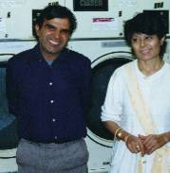

- Direct swap: Fred helps Tony - Tony helps Fred
- Delayed swap: Jane helps Sue now - Sue helps Jane at some point
- All-around swap: Des helps Jim - Jim helps Amy - Bill helps Des

MUTUAL EXCHANGE

Michael Young and Gerard Lemos say mutual aid is one of the basic building blocks of community:

'The first and most humble meaning [of mutual aid] is of more or less simultaneous reciprocity between two people. A looks after B when A is ill and B looks after A when A is ill.

The second and less humble meaning is lagged reciprocity ...Friends and neighbours might help one another ... with no immediate return, but with strong implicit presumption of help to be returned at an unspecified moment of future need.

The third ...meaning is where mutuality is multilateral - three ways, or four ways, or n-ways. A helps B. B helps C. C helps A. This multilateral aid can be stretched to include millions of people who are unknown, but although unknown, contribute to the welfare of each and every one of us.'’

In the support of vulnerable people, Gerard Lemos maintains that 'mutual aid is the missing link'.

IDENTIFYING GIFTS

Judith Snow has written that everyone has at least two gifts – presence and difference - and these enable meaningful interaction and the building of society as we know it.

In reality, of course, everyone has many gifts – a unique collection of individual capacities and qualities.

Talking about our gifts doesn’t come easily to many of us Britons. We often prefer self-deprecation. This is OK for Hugh Grant movies but no good for community building.

To help us identify gifts, a simple framework can be used:

GIFTS MAP

Identity Interests

Gifts Skills

When mapping gifts, we should not rush too quickly into deciding something is a deficit. Being a heavy smoker may not be good for health, but it may be a quality respected by other heavy smokers and a useful entry point in making connections.

John McKnight warns us to watch out when deciding something is a deficit.

Community Building in Logan Square gives an account of how the gifts of disabled people can be identified and the community made stronger. Bill, for example, is a man who lives in a group home and was isolated. McKnight says photographs of Bill's smiling face show his unique gift: he is the most joyful person known to the community building initiative in Logan Square. Where could this ‘gift of joy’ be received? They looked for the most joyless place in the neighbourhood and came up with the hospital.

Bill works as a volunteer twice a week in the mailroom. Despite colour coded mail batches, he sometimes drops mail at the wrong departments. This forces departments to speak to each other. The administrator claims Bill has achieved more for in-service communication than all the consultants working on the communications problem.

Mixing up mail - deficit or gift?

FINDING THE BEST PLACE TO USE THESE GIFTS

What works –
what places people and activities create
enthusiasm, enjoyment and fulfilment?

What doesn’t work –
what places people and activities create
boredom or frustration?
By plotting a hierarchy of places – from those where someone feels comfortable, excited, energised and moving progressively down to those where someone is likely to feel bored, frustrated or anxious, we can focus our energies and maximise chances of successful connection.

MAPPING RELATIONSHIPS

A third simple tool to help us get going is the relationship map:

Exchange
Participation

Friendship

Intimacy

Adapted from Judith Snow

Before using this with people we work with, it is advisable to do it for ourselves. Write in the names of those in your circles.

Intimacy – close family and friends – essential people in your life.
Friendship – people you like to spend time with, people in a reciprocal relationship with you – trusting and caring.
Participation – work colleagues, acquaintances, fellow members of clubs or associations who you particularly like to be with, etc.
Exchange – people who are paid to be in your life: doctor, barber, home help etc.

LOCATING COMMUNITY ASSETS

John McKnight’s studies have revealed that there are 5 components discernible in community building efforts:

Individuals with their gifts

Groups and associations
Systems: services; institutions; businesses; councils etc.
Resources such as the buildings and the land
The economy.

McKnight says that studies carried out by his Institute revealed that, in conscious connection work with excluded groups, successes were mostly achieved by associations – few by institutions and services.

In the UK, services (including service representatives at this training) want to take the lead in connecting people. We can, nonetheless, learn from McKnight’s lesson.

Associations are groups of unpaid people who gather together for a common purpose or interest – perhaps at the karaoke night at the pub, or a group of people concerned about road safety in their street. These may be very organised – such as campaigns – or very loose such as baby-sitting exchanges or groups who gather to go to football matches.

Groups and associations are an underused resource in our efforts to connect people – a resource that can be strengthened by the inclusion of the gifts of labeled people.

COMMUNITY MAPS

There are many ways of mapping – starting with a door-to-door questionnaire to individuals. Most of us are unlikely to do this. But we can map communities fairly readily.

Collect information from the local area:

- Associations – organised and loose
- Helpful people
- Good places to hang out
- Meeting places – pubs, cafes, shops, launderette etc.
- Community groups
- Local resources
- Services – e.g. doctors, voluntary organisations, hospital, police

Go out and walk the streets; talk to people; ask who are the key people in the neighbourhood – the people who seem to know everyone - talk to them. Use questionnaires – or any other means which you can dream up.

In talking to people in the neighbourhood, use tactics you are comfortable with. The most straightforward is: to say ‘I’m interested in finding out how many clubs and groups there are here’, and conducting a loose interview:

- Do you belong to any groups or clubs – don’t have to be formal?
- Which?
- Do you know of others?
- Who do you know in them?
- Who is the best person to contact?
- Do you know someone who knows a lot about the neighbourhood?

Draw the map onto big pieces of paper (ends of newsprint rolls from the skips of newspaper publishers is ideal). Involve the people you are supporting as much as possible.

Use lots of colour, photos, quotes. Mapping can be an interesting and inspiring project and the product can be a picture that can be turned into posters or used in local authority guides. It can be shared with the community as well.

CONNECTING PEOPLE

We have located people’s gifts and the assets of the neighbourhod. Now we come to the part about linking the two.

Ask – introduce someone in a way which enables the person to be welcomed on an exchange basis – not a charity basis.

Tom Kohler’s ideas for creating ‘useful unions’ – any connection which will enrich any part of someone’s life – may be helpful. He suggests that the person playing the connector role should:

- Remember that our credibility as the connector is not based on credentials but on who we are.
- Present a positive image of someone – first impressions count. We can influence a more positive equation. The image we present affects the outcome of the interaction:

Image Attitude of those meeting person Action

Interaction Image

- Get our p’s straight – stop thinking of people as ‘patients, problems, part of a project’. Instead strengthen the link between Personal and Professional – bring these two areas of our lives closer.
- Make a personal commitment – neither idealising community nor writing it off. Instead we need to make a commitment to do our part in making the real community a place a better place to be.
- Recognise that people are interested not in what a person is like, but rather what it is like to spend time with the person – to share an experience with them.
- Invite people to suspend their preconceptions about labeled people long enough for them to meet the person.
- Be a competence monger – lead on people’s unique qualities and abilities. This invites respect.
- Use shared interests or shared pasts.

Other important aspects of introducing someone:

- Learn to tell people’s stories in a way which has been agreed – and avoiding the pitfalls of paternalism, patronising, professionalising, pitying – be positive (and truthful).
- Be yourself – people can tell if you’re just doing this because it’s your job – passion shows.
- Don’t do it if you don’t like the person.

SOME SUGGESTIONS FOR ACTION

- Do your own gifts map with someone who knows and likes you.

- Make a map of your own community – go out on the street and talk to people – say you want to find out how many associations there are in the area – find out what people are really like – challenge your assumptions – stretch your knowledge of your area.

- Use the tools in this handout with someone – or a group – who you support. Do gifts maps and community maps– engage people in mapping the area.

- Make some introductions.

- Form a community building action learning set – meet up to find out how it went – look at what worked and what didn’t work so well – refine your asking techniques – try again.

SOME READING

M. O’Connell, Community Building in Logan Square – How a community grew stronger with the contributions of people with disabilities; Chicago, 1990. (Available as a download from http://www.northwestern.edu/ipr/publications/papers/logansq.pdf

M. Young & G. Lemos, The Communities We Have Lost and Can Regain, London, 1997

J McKnight and J Kretzmann, Building Communities from the Inside Out, Chicago.

J McKnight, A Guide to Capacity Inventories – Mobilising the Community Skills of Local Residents, Chicago.

J McKnight, The Careless Society – Community and its Counterfeits, New York, 1995

(All John McKnight’s publications available from: ACTA Publications, 4848 North Clark St, Chicago IL 60640. Fax: 312 271 7399.)

J O’Brien and C L O’Brien, Members of Each Other, 1997, (Available Inclusion Press).

H Sanderson, J Kennedy et al, Friendship and Community, North West Training and Development Team.

Elfrida Press, Participation North and South – New ideas in participatory development from India and the UK, 2003 (available www.elfrida.com).

S Duffy, Keys to Citizenship, Paradigm 2003

M. Young & G. Lemos, The Communities We Have Lost and Can Regain, London, 1997
M. O’Connell, Community Building in Logan Square – How a community grew stronger with the contributions of people with disabilities; Chicago, 1990. (Available as a download from www.nwu.edu/IPR/abdc.html)

